Veterans Benefits Banking Program (VBBP)
Social Media Content Toolkit

Overview
The U.S. Department of Veterans Affairs (VA), in partnership with the Association of Military Banks of America (AMBA), launched the Veterans Benefits Banking Program (VBBP), available starting December 20th, 2019. The program will provide Veterans and their beneficiaries the chance to safely, reliably and inexpensively receive and manage their VA monetary benefits through financial services at participating banks. The content below includes information about the VBBP program and promote financial literacy within the Veteran community.

Topics
- VBBP Launch Day (12/20)!
- What is VBBP?
- VBBP has been launched!
- Holiday spending/financial literacy
- Why is VA implementing VBBP?
- New Year, new you (#NewYearsResolution)

Graphics
- Find links for each graphic on their respective posts below.

Campaign links
- VBA: www.benefits.va.gov/banking
- VBBP: www.veteransbenefitsbanking.org

Hashtags
- #VeteransBenefitsBanking
- #BestYearEver
- #HappyHolidays
- #NewYearsResolution

VBBP Launch Day (12/20)!
Recommended post date: 12/20

Facebook
(View the Facebook graphic for this posting below.)
Life comes with plenty of challenges, but banking shouldn’t be one of them. Effective TODAY, December 20th, all Veterans and their beneficiaries who receive financial benefits through VA are eligible to take advantage of the new Veterans Benefits Banking Program in partnership with the @MilitaryBanks. Learn more at https://benefits.va.gov/banking #VeteransBenefitsBanking #BestYearEver

Twitter
(View the Twitter graphic for this posting below.)
Life has plenty of challenges, but banking shouldn’t be one. TODAY 12/20, all Veterans who receive VA financial benefits can enroll in the #VeteransBenefitsBanking Program with @MilitaryBanks. Learn more: https://benefits.va.gov/banking #BestYearEver

Instagram
(View the Instagram graphic for this posting below.)
Life has plenty of challenges, but banking shouldn’t be one of them. Effective TODAY, December 20th, all Veterans and their beneficiaries who receive VA financial benefits are eligible to enroll in the Veterans Benefits Banking Program in partnership with the Association of Military Banks of America.
Learn more at benefits.va.gov/banking
#VeteransBenefitsBanking #BestYearEver

LinkedIn
(View the LinkedIn graphic for this posting below.)
Life comes with plenty of challenges, but banking shouldn’t be one of them. Effective TODAY, December 20th, all Veterans and their beneficiaries who receive financial benefits through VA are eligible to take advantage of the new Veterans Benefits Banking Program in partnership with the Association of Military Banks of America.
Learn more at https://benefits.va.gov/banking #VeteransBenefitsBanking #BestYearEver

Topic: What is VBBP?
Recommended post dates: 12/23 – 12/27

Facebook
(View the Facebook graphic for this posting below.)
On Friday, December 20th, @VeteransBenefits launched the Veterans Benefits Banking Program, in partnership with the Association of Military Banks of America (@MilitaryBanks)! The program will provide Veterans with increased banking options, support, and guidance to achieve greater financial independence, resiliency, and literacy. More banking options for our Veterans and beneficiaries will allow for secure ways to electronically receive and manage their VA benefits.
https://www.benefits.va.gov/banking
#VeteransBenefitsBanking #BestYearEver

Twitter
(View the Twitter graphic for this posting below.)
The @VAVetBenefits #VeteransBenefitsBanking Program with @MilitaryBanks launched on 12/20! Veterans will have more banking options, support, and guidance to achieve greater financial independence, resiliency, and literacy. https://www.benefits.va.gov/banking #BestYearEver

Instagram
(View the Instagram graphic for this posting below.)
The Veterans Benefits Banking Program launched on Friday, December 20th! The @VABenefits partnering with the Association of Military Banks of America (AMBA), Veterans will be provided with increased banking options, support, and guidance to achieve greater financial independence, resiliency, and literacy. More banking options will allow for secure ways to electronically receive and manage VA benefits.
Learn more at benefits.va.gov/banking
#VeteransBenefitsBanking #BestYearEver

Topic: VBBP has been launched!
Recommended post dates: 12/20 – 12/23

Facebook
(View the Facebook graphic for this posting below.)
The new Veterans Benefits Banking Program has launched! Are you a Veteran receiving VA financial benefits that has had trouble opening a bank account? As of December 20th, @VeteransBenefits’ partnership with the @MilitaryBanks can offer you access to increased banking options and financial support.
Learn more at https://www.benefits.va.gov/banking
#VeteransBenefitsBanking #BestYearEver

Twitter
(View the Twitter graphic for this posting below.)
The @VAVetBenefits #VeteransBenefitsBanking Program with @MilitaryBanks has launched! Have you ever had trouble opening a bank account? Veterans receiving VA financial benefits will have access to more banking options and financial support. https://www.benefits.va.gov/banking #BestYearEver

Instagram
(View the Instagram graphic for this posting below.)
The new Veterans Benefits Banking Program has launched! Are you a Veteran receiving VA financial benefits that has had trouble opening a bank account? Our partnership with the Association of Military Banks of America (AMBA) can offer you access to increased banking options and financial support.
Learn more at benefits.va.gov/banking
#VeteransBenefitsBanking #BestYearEver

Topic: Holiday spending/financial literacy
Recommended post dates: 12/23 – 12/27

Facebook
(View the Facebook graphic for this posting below.)
Spend your money on presents for your family and not on scams this holiday season! @VeteransBenefits and its partners provide resources to assist with managing your personal finances.
Learn what you can do to protect yourself from identity theft, get free financial resources, and other federal and private resources: https://benefits.va.gov/banking
#VeteransBenefitsBanking #HappyHolidays #BestYearEver

Twitter
(View the Twitter graphic for this posting below.)
Spend money on presents, not scams this holiday season! @VAVetBenefits and its partners provide resources to assist with managing your personal finances. Learn about the #VeteransBenefitsBanking Program at https://benefits.va.gov/banking #BestYearEver

Instagram
(View the Facebook graphic for this posting below.)
Spend your money on presents for your family and not on scams this holiday season! VBA and its partners provide resources to assist with managing your personal finances.
Go to https://benefits.va.gov/banking to learn what you can do to protect yourself from identity theft, get free financial resources, and other federal and private resources.
#VeteransBenefitsBanking #HappyHolidays #BestYearEver

Topic: Why is VA implementing VBBP?
Recommended post dates: 12/27 – 12/31

Facebook
(View the Facebook graphic for this posting below.)
Veterans are facing increasing financial challenges created by scams and unsavory business practices targeted at Veterans and servicemembers members. The Veterans Benefits Banking Program, in partnership with the @MilitaryBanks, was launched because it is critical that Veterans receiving VA monetary benefits have access to the kind of regulated, safe, and reliable financial services banks can provide.
Learn more at https://www.veteransbenefitsbanking.org/
#VeteransBenefitsBanking #BestYearEver

Twitter
(View the Twitter graphic for this posting below.)
Scams create constant financial challenges for Veterans. The #VeteransBenefitsBanking Program with @MilitaryBanks gives Veterans receiving VA monetary benefits access to regulated, safe, and reliable financial services. https://www.veteransbenefitsbanking.org #BestYearEver

Instagram
(View the Instagram graphic for this posting below.)
Veterans face constant financial challenges created by scams and unsavory business practices that target Veterans and servicemembers. The Veterans Benefits Banking Program was launched in partnership with the Association of Military Banks of America so Veterans receiving VA monetary benefits can access regulated, safe, and reliable financial services.
Learn more at benefits.va.gov/banking
#VeternsBenefitsBanking #BestYearEver

Topic: New Year, new you (#NewYearsResolution)
Recommended post dates: 1/1 – 1/5

Facebook
(Facebook graphic TBD)
New Year, new you! Make financial stability your 2020 #NewYearsResolution. Take advantage of the Veterans Benefits Banking Program in partnership with @MilitaryBanks to get your finances settled.
https://www.benefits.va.gov/banking
#VeteransBenefitsBanking #BestYearEver

Twitter
(Twitter graphic TBD)
New Year, new you! Make financial stability your 2020 #NewYearsResolution. Take advantage of the #VeteransBenefitsBanking Program in partnership with @MilitaryBanks to get your finances settled. https://benefits.va.gov/banking #BestYearEver

Instagram
(Instagram graphic TBD)
New Year, new you! Make financial stability your 2020 #NewYearsResolution. Take advantage of the Veterans Benefits Banking Program in partnership with the Association of Military Banks of America to get your finances settled. To get started, go to benefits.va.gov/banking
#VeteransBenefitsBanking #BestYearEver

Graphics

Topic: VBBP Launch Day!

Facebook, Twitter and LinkedIn Graphic

Instagram Graphic

Topics: What is VBBP? and VBBP has been launched!

Facebook Graphic
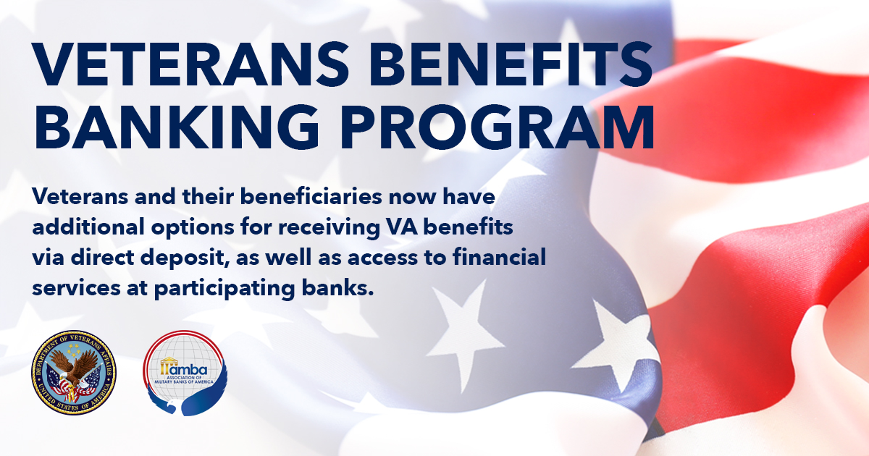

Twitter Graphic
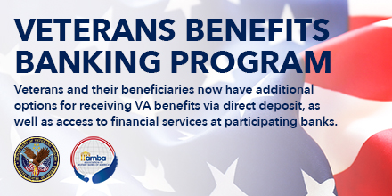

Instagram Graphic
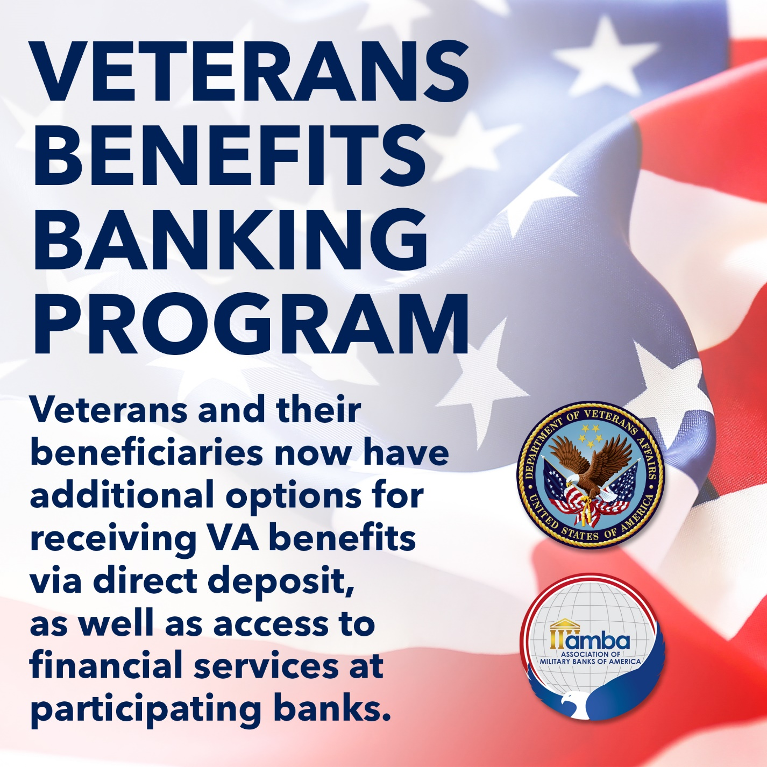

Topic: Holiday spending/financial literacy

Facebook and Twitter Graphic
Source: https://unsplash.com/photos/mpnqu9o4b9w

Instagram Graphic
Source: https://unsplash.com/photos/mpnqu9o4b9w

