Section F. Docketing, Certification, and Claims Folder Transfer

Overview

In this Section | This section contains the following topics:

Topic | Topic Name | See Page
25 | Docketing Substantive Appeals | 5-F-2
26 | Certifying Substantive Appeals | 5-F-3
27 | VA Form 646, Statement of Accredited Representative in Appealed Cases | 5-F-6
28 | Transferring the Claims Folder | 5-F-10
29 | Receiving Evidence and Changes after Certification and Transfer | 5-F-13
30 | Advancing a Case on the Board of Veterans’ Appeals (BVA) Docket | 5-F-18
31 | Exhibit 1: Certification Worksheet | 5-F-22
32 | Exhibit 2: BVA Points of Contact | 5-F-28

25. Docketing Substantive Appeals

Introduction | This topic contains information on docketing substantive appeals, including  - adding appeals to BVA’s docket, and  - notification by BVA.

Change Date | August 4, 2009

a. Adding Appeals to BVA’s Docket | Add appeals to the Board of Veterans’ Appeals (BVA) docket by updating the Veterans Appeal Control and Locator System (VACOLS)  - immediately following the receipt of VA Form 9, Substantive Appeal, at the regional office (RO), and  - without requiring BVA to physically take possession of the related claims folder.  Notes:  - When the RO enters the date of receipt of the VA Form 9 into VACOLS, VACOLS will  - reserve a slot on the docket based on the date entered, and  - assign the Docket Number when BVA receives the appeal.  - The related claims folder will remain at the RO until it is certified as ready for BVA review. Once the claims folder is certified, it will be transferred to BVA immediately, unless the folder must remain at the RO because a BVA Travel Board or videoconference hearing has been scheduled.  Reference: For more information on tracking appeals in VACOLS, see the VACOLS User Guide.

b. Notification by BVA | BVA sends a docket notification letter that  - notifies the appellant  - that his/her appeal has been added to BVA’s docket  - that all appeals will be considered in docket number order  - what docket number has been assigned to the appeal, and  - what telephone number to use to obtain general information, and  - includes two pamphlets providing information about the appeal.

26. Certifying Substantive Appeals

Introduction | This topic contains information on certifying substantive appeals, including  - the certification process  - when to certify an appeal  - when not to certify an appeal  - the Veteran Service Representative’s (VSR’s) review of the claims folder  - the Decision Review Officer’s (DRO’s) or Veterans Service Center Manager’s (VSCM’s) review of the claims folder, and  - completing VA Form 8, Certification of Appeal.

Change Date | August 4, 2009

a. Certification Process | The Decision Review Officer (DRO), Veterans Service Center Manager (VSCM), or his/her designee is responsible for  - reviewing all appeals, and  - certifying that the appeal is ready for review by BVA.  Proper review of the case includes verification that all  - issues on appeal have been decided and discussed, and  - appropriate development has been initiated and properly disposed of.
Continued on next page
26. Certifying Substantive Appeals, Continued

b. When to Certify an Appeal | Certify the appeal after obtaining (or exhausting all efforts to obtain) all available and relevant evidence.  If the appeal is based on a rating or authorization decision, the appropriate activity should review the appeal to  - determine if all  - issues raised on appeal have been identified, and  - contentions and allegations made by the appellant or his/her representative have been properly and adequately addressed, and  - confirm that all evidence is of record, including service treatment records (STRs), if appropriate.

c. When Not to Certify an Appeal | In any case in which final action is delayed to permit the submission of additional evidence, do not certify an appeal until the period for submission of the evidence has expired.  Reference: For more information on time limits, see M21-1MR, Part I, 5.B.4.

d. VSR Review of Claims Folder | The Veterans Service Representative (VSR) or other Veterans Service Center (VSC) employee  - updates VACOLS for receipt of a substantive appeal, and  - refers the claims folder to the DRO, VSCM, or his/her designee.  Note: The VSCM designee is an employee, such as a senior Rating VSR or Appeals Team Coach, who is well versed in the appellate process and the issue under appeal.
Continued on next page
26. Certifying Substantive Appeals, Continued

e. DRO or VSCM Review of Claims Folder | The DRO, VSCM, or his/her designee  - reviews the claims folder  - verifies that all  - issues on appeal have been decided  - appropriate development has been initiated and properly disposed of, and  - completes the certification worksheet  - ensures that  - all necessary development was accomplished  - the statement of the case (SOC) was adequate, and  - all issues raised have been considered  - remedies any deficiencies through additional development or a supplemental statement of the case (SSOC), and  - gives the representative of a service organization an opportunity to execute and return VA Form 646, Statement of Accredited Representative in Appealed Case, prior to certification.  References:  - For a sample of the certification worksheet, see M21-1MR, Part I, 5.F.31.  - For more information on the review and statement by an accredited service organization representative, see M21-1MR, Part I, 5.F.27.

f. Completing VA Form 8 | Complete VA Form 8, Certification of Appeal, to certify the appeal when it is ready for review by BVA. Cite only those issues on appeal. If the appeal is enlarged to include addition issues, certify all related issues on appeal to BVA.

27. VA Form 646, Statement of Accredited Representative in Appealed Cases

Introduction | This topic contains information on VA Form 646, Statement of Accredited Representative in Appealed Cases, including  - the purpose of VA Form 646  - executing VA Form 646  - prior to certification  - for remanded appeals  - preparing and sending VA Form 646  - reviewing the representative’s arguments, and  - completing VA Form 646.

Change Date | August 4, 2009

a. Purpose of VA Form 646 | VA Form 646, Statement of Accredited Representative in Appealed Cases, gives an appellant’s representative an opportunity to review the appeal and submit a statement regarding the appeal  - prior to certification, and/or  - after  - receiving new evidence requiring additional action, or  - completing an action on a BVA-remanded appeal.

b. Executing VA Form 646 Prior to Certification | VA Form 646 can be executed prior to certification of an appeal when  - a hearing was not conducted  - a hearing was conducted but the representative did not participate  - additional evidence was submitted during or subsequent to the  - hearing, or  - execution of VA Form 646, or  - exceptional circumstances indicate that an opportunity should be extended to the representative to execute VA Form 646.
Continued on next page
27. VA Form 646, Statement of Accredited Representative in Appealed Cases, Continued

c. Executing VA Form 646 for Remanded Appeals | VA Form 646 can be executed in remanded cases when further consideration is required by BVA.  Note: VA Form 646 is not required when  - new evidence is not submitted and additional actions were not required, or  - an appeal is  - remanded by BVA solely for assembly of records, such as X-ray films or outpatient treatment folders, and  - forwarded without further consideration by the agency of original jurisdiction.
Continued on next page
27. VA Form 646, Statement of Accredited Representative in Appealed Cases, Continued

d. Preparing and Sending VA Form 646 | Prepare a memo for the representative that requests completion of VA Form 646 and states the time limits for submission. Send the memo to the representative and place a copy of it in the claims folder for record purposes.  Note: Determine the entry for “Reply Requested by [date]” in accordance with locally-established rules designed to prevent unwarranted delay. The recommended range is five to eight days.  If the representative  - does not return VA Form 646 within the time limit for submission  - follow up the request for completion after five working days have passed since submission, and  - annotate the file with the date of the follow-up.  - does not return VA Form 646 within a reasonable amount of time, such as the second workday after the date of “Reply Requested”  - annotate the control copy of VA Form 646 as “646 not executed”  - date and initial the copy, and  - file it in the claims folder.  - requests an extension, refer the request to the VSCM or his/her designee to decide if the request should be granted.  Reference: For more information on certification and transfer of the appeal to BVA, see  - M21-1MR, Part I, 5.F.26, and  - M21-1MR, Part I, 5.F.28.
Continued on next page
27. VA Form 646, Statement of Accredited Representative in Appealed Cases, Continued

e. Reviewing the Representative’s Arguments | Carefully review  - VA Form 646, and  - the representative’s arguments.  Use the table below to respond to the representative’s arguments on VA Form 646.

If the representative … | Then …
indicates that there may be additional evidence in support of the claim | undertake the necessary development.
raises new issues | go to M21-1MR, Part I, 5.E.24.
asserts that statutes or regulations other than those sited in the SOC apply to the appeal | - consider if issuance of an SSOC is appropriate, and  - issue an SSOC only if the SOC was erroneous in not including those citations.
- cites U.S. Court of Appeals for Veterans Claims (CAVC) decisions to support the claim, and  - explains how any CAVC decisions cited apply to the particular appeal | - carefully review the appeal for errors or deficiencies that may exist based on the CAVC decision cited  - correct any errors or deficiencies found, and  - issue an SSOC.  Note: Do not issue an SSOC if no errors or deficiencies are found.
offers only argument | do not issue an SSOC. BVA will consider the representative’s argument.

f. Completing VA Form 646 | Complete the entries in the heading of VA Form 646  - prior to certification, and/or  - upon request by BVA for the temporary transfer of the claims folder.

28. Transferring the Claims Folder

Introduction | This topic contains information on transferring the claims folder, including  - receiving evidence prior to transferring the claims folder to BVA  - when to transfer the claims folder to BVA  - procedure for transferring the claims folder, and  - permanently transferring the claims folder to another RO.

Change Date | August 4, 2009

a. Receiving Evidence Prior to Transferring Claims Folder to BVA | Use the table below to process evidence received prior to transfer of the claims folder to BVA.

If the evidence … | Then …
was requested by the RO | - refer the evidence to the appropriate  - DRO  - rating activity, or  - authorization activity, and  - permit the personal appearance of the appellant or his/her representative in connection with the consideration of such additional evidence.
is received after an appeal has been certified to BVA, but before the claims folder is transferred | - retain the claims folder  - refer the evidence to the appropriate  - DRO  - rating activity, or  - authorization activity  - notify BVA of the  - delay, and  - estimated date when the folder will be forwarded, and  - forward the claims folder and all other records relating to the issue on appeal to BVA, upon request.
Continued on next page
28. Transferring the Claims Folder, Continued

b. When to Transfer Claims Folder to BVA | Route the claims folder for transfer to BVA after  - VA Form 8 is signed by the DRO, VSCM, or his/her designee  - all correspondence is released  - VACOLS is updated, and  - The VSC creates a temporary claims folder containing copies of  - VA Form 8  - the latest rating decision  - the latest award letter, and  - any other pertinent documents that may be needed to adjudicate any new or supplemental claims while the claims folder is temporarily transferred to BVA.  Important: Do not create an additional volume of a claims folder in the Control of Veterans Records System (COVERS) while the original claims folder is temporarily located at BVA. Instead, create a temporary folder to house copies of the documents listed above.  Reference: For information on  - evidence received after transfer of the claims folder to BVA, see M21-1MR, Part I, 5.F.29.a, and  - COVERS folder operations, see the COVERS User Guide.

c. Procedure for Transferring Claims Folder | Follow the steps in the table below to transfer the claims folder to BVA when the case is ready for BVA review.

Step | Action
1 | Update VACOLS by entering the date the appeal was certified to BVA.  Result: The claims folder and all associated evidence will be immediately transferred to BVA.
Continued on next page
28. Transferring the Claims Folder, Continued

c. Procedure for Transferring Claims Folder (continued)

Step | Action
2 | Prepare a locally-generated letter to notify the appellant that the appeal has been certified and transferred to BVA.  If a hearing was requested before BVA in Washington, DC, add the following statement to the letter:  “You will be advised by the Board concerning your request for a hearing.”  Note: Do not use the letter generated by the Benefits Delivery Network (BDN).
3 | - Send copies of the locally-generated letter to the  - appellant  - representative, and  - other interested persons, if any, and  - ensure that a copy of the letter is in the claims folder when it is forwarded to BVA.  Notes:  - If the appellant’s address is not known  - continue to forward the appeal to BVA, and  - send notice to the appellant at the last known address.  - Receipt of VA Form 9 places it under BVA jurisdiction.

d. Permanently Transferring Claims Folder to Another RO | To permanently transfer the claims folder to another RO  - indicate the new RO location on the claims folder  - update  - the address, and  - VACOLS to reflect the transfer of the claims folder to the receiving RO, and  - transfer the claims folder and all evidence relating to the appeal to the other RO.

29. Receiving Evidence and Changes after Certification and Transfer

Introduction | This topic contains information on receiving evidence and changes after certification and transfer, including  - receiving evidence after certification and transfer  - requesting temporary return of the claims folder  - receiving unrelated claims after certification and transfer  - receiving a change of address after certification and transfer  - guidelines for changing representation after certification and transfer  - receiving a change in representation after certification and transfer  - guidelines for requesting a hearing after certification and transfer, and  - receiving a request for a hearing after certification and transfer.

Change Date | March 28, 2011

a. Receiving Evidence after Certification and Transfer | Consideration of appeals involves studying all evidence available relating to the issue presented. Follow the steps in the table below when evidence is received after an appeal has been certified and the claims folder has been transferred.

Step | Action
1 | Review the copy of VA Form 8 that has been retained in the temporary claims folder.
2 | Determine the relationship of the evidence to the issue under BVA review.
Continued on next page
29. Receiving Evidence and Changes after Certification and Transfer, Continued

a. Receiving Evidence after Certification and Transfer (continued)

Step | Action
3 | Is the evidence related to the issue under BVA review?  - If yes, forward the new evidence to BVA, together with  - a copy of the associated VACOLS screen, and/or  - a copy of VA Form 8.  Notes:  - If BVA determines that the evidence was received timely, BVA will seek a waiver of initial RO consideration from the appellant and consider whether a remand to the RO is merited.  - Upon receipt of supplemental service treatment records (STRs) that are pertinent to an issue under appeal  - make copies of the STRs and place them in the temporary folder  - forward the original STRs to BVA as stated above, and  - maintain end product (EP) 699 control until the claims folder is returned.  - If no, obtain the information needed to process the unrelated claim from the claims folder by  - calling or faxing the appropriate BVA team, or  - requesting temporary return of the claims folder.  References:  - For a list of BVA points of contact, see M21-1MR, Part I, 5.F.32.  - For more information on  - requesting return of the folder, see M21-1MR, Part I, 5.F.29.b  - handling claims received while the folder is at General Counsel awaiting CAVC processing, see M21-1MR, Part I, 5.J.48  - obtaining a waiver of initial consideration of evidence, see Disabled American Veterans et al. v. Secretary, Case Nos. 02-7304, -7305, -7316 (Fed. Cir. May 1, 2003) and VAOPGCPREC 1-2003, and  - the time limit for submission of additional evidence, see 38 CFR 20.1304.
Continued on next page
29. Receiving Evidence and Changes after Certification and Transfer, Continued

b. Requesting Temporary Return of Claims Folder | When you receive unrelated evidence, and the claims folder is essential to adjudication of a claim unrelated to the appeal issue  - contact the appropriate BVA staff point of contact shown in M21-1MR, Part I, 5.F.32, and  - furnish the  - appellant’s name  - appellant’s claim number, and  - reason for requesting the claims folder.  Result: BVA determines whether the claims folder can be returned to the RO. If BVA cannot return the claims folder immediately, BVA will indicate the anticipated date of return.

c. Receiving Unrelated Claims after Certification and Transfer | If an unrelated claim is received while the appellant’s claims folder is before BVA  - place the claim under control, and  - act on it as soon as possible.  Note: CAVC has stated that undue delay on new claims will not be tolerated.  Reference: For more information on unrelated claims, see Ebert v. Brown, 4 Vet. App. 434 (1993).
Continued on next page
29. Receiving Evidence and Changes after Certification and Transfer, Continued

d. Receiving a Change of Address After Certification and Transfer | If a change of address is received after certification or transfer, refer the claim for VACOLS input.

e. Guidelines for Changing Representation After Certification and Transfer | An appellant may submit a request for a change in representation  - within 90 days from the mailing of notice that an appeal has been certified to BVA, or  - until the date the appellate decision is made by BVA, whichever comes first.  After this time period, BVA may permit a change in representation for good cause. BVA will determine if the request to change representatives can be accepted.

f. Receiving a Change in Representation After Certification and Transfer | If notice is received of the appointment by the appellant of a new representative after certification and transfer of the appeal to BVA  - send the request for a change in representation directly to BVA, not the RO  - update the following systems to reflect the new power of attorney code:  - VACOLS  - the Beneficiary Identification Records Locator Subsystem (BIRLS)/Share, and  - BDN/Share, including the pending issue file (PIF), if necessary.  - forward the document appointing the new representative to BVA, and  - keep a photocopy for the drop file pending return of the claims folder.  Reference: For more information on receiving a change in representation after certification and transfer, see 38 CFR 20.1304.
Continued on next page
29. Receiving Evidence and Changes after Certification and Transfer, Continued

g. Guidelines for Requesting a Hearing After Certification and Transfer | An appellant may submit a request for a hearing on an appeal  - within 90 days from the mailing of notice that an appeal has been certified and transferred to BVA, or  - until the date the appellate decision is established by BVA, whichever comes first.  Note: BVA will determine if a hearing can be scheduled.  Reference: For more information on guidelines for requesting a hearing after certification and transfer, see 38 CFR 20.1304.

h. Receiving a Request for a Hearing After Certification and Transfer | Send requests for a hearing directly to BVA, not the RO. If a request is received at the RO, forward it to BVA.  Reference: For more information on receiving a request for a hearing after certification and transfer, see 38 CFR 20.1304.

30. Advancing a Case on the Board of Veterans’ Appeals (BVA) Docket

Introduction | This topic contains information on advancing a case on the Board of Veterans’ Appeals (BVA) docket, including  - the reasons for advancing a case on the BVA docket  - the process for advancing a case on the BVA docket  - handling an advanced motion from an appellant or his/her representative  - forwarding the advanced motion from the appellant or his/her representative, and  - BVA’s acknowledgement of an appellant’s advanced motion.

Change Date | August 4, 2009

a. Reasons for Advancing a Case on the BVA Docket | Normally, BVA considers cases in the order of their placement on the docket. However, 38 U.S.C. 7107 allows an advance on the docket for good cause.  In this case, good cause includes, but is not limited to  - an appellant’s  - terminal illness  - advanced age, and/or  - extreme financial hardship, and/or  - matters concerning an interpretation of a law that, when generally applied, may affect the claims of other Veterans and/or their dependents.  Note: Status as a former prisoner of war (POW), in itself, is not a sufficient cause for requesting an advance on the docket.
Continued on next page
30. Advancing a Case on the Board of Veterans’ Appeals (BVA) Docket, Continued

b. Process for Advancing a Case on the BVA Docket | The table below describes the process for advancing a case on the BVA docket, if advancement is warranted at the pre-certification step.

Stage | Description
1 | The VSR prepares a memorandum to send to the VSCM. This memorandum documents all factors that he/she believes to warrant an advance on the BVA docket.
2 | If the VSCM  - approves the request, go to Stage 3, or  - does not approve the request  - the VSCM prepares a note to that effect over his/her signature, and  - the VSR places the note in the claims folder.  Important: The VSCM may not delegate authority to approve a request for an advance on the docket. However, in the absence of the VSCM, the Assistant or Acting VSCM may assume the authority.
3 | The VSR  - prepares a letter to the Chairman of BVA requesting an advance on the docket, including the detailed reasons that warrant the advance  - obtains the signature of the RO Director on the letter  - attaches the letter to the claims folder, and  - sends the claims folder to BVA.
4 | If BVA  - approves the request, BVA includes a statement in their decision regarding the approved request for an advance on the docket, or  - denies the request, BVA immediately notifies the appellant and/or his/her representative.
Continued on next page
30. Advancing a Case on the Board of Veterans’ Appeals (BVA) Docket, Continued

c. Handling an Advanced Motion From an Appellant or His/Her Representative | If the appellant or his/her representative requests an advance on the BVA docket, the VSCM does not rule on the merits of the motion.  Instead, attach the motion to the letter prepared for the Chairman of BVA. Use appropriate language in the letter to refer to the motion in lieu of a detailed explanation of the reasons for the advance on the docket.

d. Forwarding an Advanced Motion from an Appellant or His/Her Representative | Use the table below to forward the motion to BVA when the appellant or his/her representative requests earlier consideration by BVA.

If the appeal is … | Then …
in BVA custody | forward the motion to BVA via transmittal stating “See attached motion to advance on BVA docket.”
not in BVA custody, regardless of jurisdictional authority | - photocopy the motion  - annotate the motion document as “Copy to BVA”  - initial and date the annotation  - return the claims folder to the next activity, and  - forward a copy of the motion to BVA via transmittal stating “See attached motion to advance on BVA docket.”
Continued on next page
30. Advancing a Case on the Board of Veterans’ Appeals (BVA) Docket, Continued

e. BVA’s Acknowledgement of Appellant’s Advanced Motion | BVA  - acknowledges the receipt of the motion to the appellant, and  - enters a ruling with respect to the disposition of the motion to advance.  Take the actions in the table below if BVA grants a motion for earlier consideration.  Reference: For more information on requests for transfer of the claims folder, see 38 U.S.C. 7107.

Step | Action
1 | BVA notifies Compensation and Pension (C&P) Service of the grant.
2 | C&P Service notifies the Veteran Service Center Manager (VSCM) at the RO where the claims folder is located
3 | The RO must forward the folder to BVA within 10 workdays from the day they were notified of the grant for earlier consideration. If the RO cannot forward the folder within 10 workdays  - the VSCM or VSCM designee must e-mail the C&P’s advance docket mailbox at VAVBAWAS/CO/21/BVA ADVANCE MOTION.  - Include in the e-mail  - an explanation on why the folder cannot be sent, and  - the approximate date the folder will be available for transfer.

31. Exhibit 1: Certification Worksheet

Change Date | August 19, 2005

a. Certification Worksheet – Page 1 | Page 1 of a sample of the certification worksheet is below.

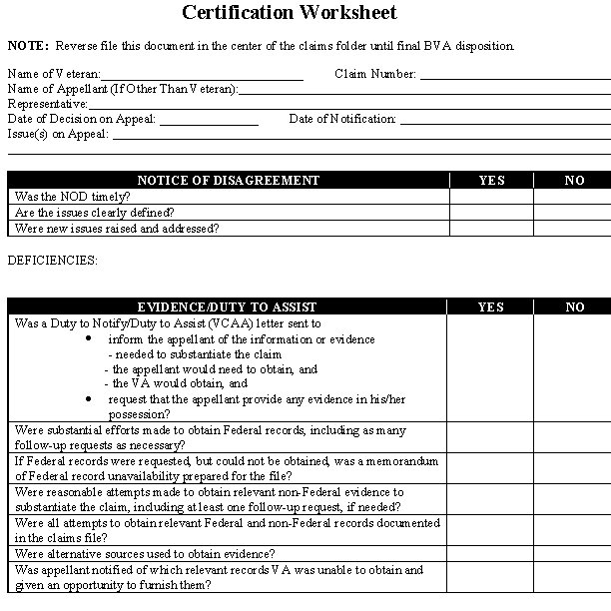
Continued on next page
31. Exhibit 1: Certification Worksheet, Continued

b. Certification Worksheet – Page 2 | Page 2 of a sample of the certification worksheet is below.

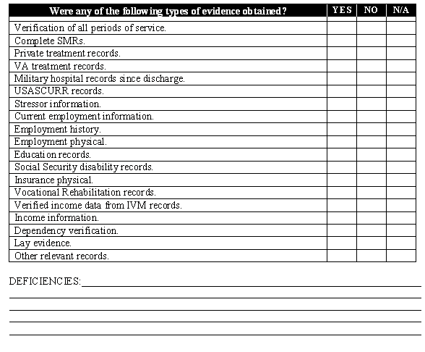

Continued on next page
31. Exhibit 1: Certification Worksheet, Continued

c. Certification Worksheet – Page 3 | Page 3 of a sample of the certification worksheet is below.

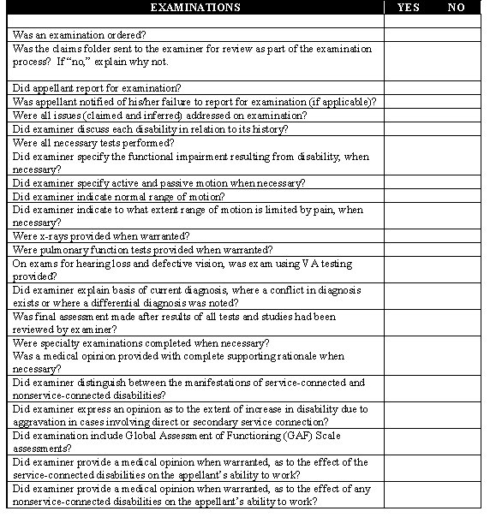
Continued on next page
31. Exhibit 1: Certification Worksheet, Continued

d. Certification Worksheet – Page 4 | Page 4 of a sample of the certification worksheet is below.

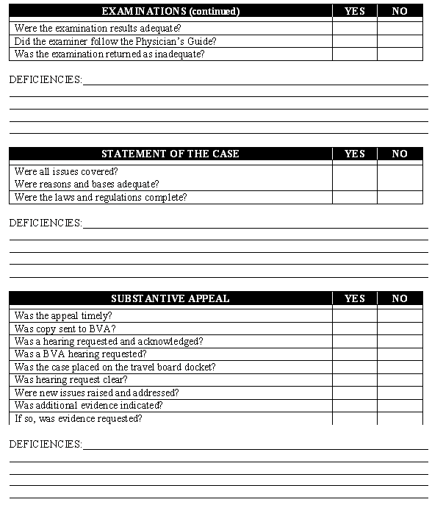
Continued on next page
31. Exhibit 1: Certification Worksheet, Continued

e. Certification Worksheet – Page 5 | Page 5 of a sample of the certification worksheet is below.

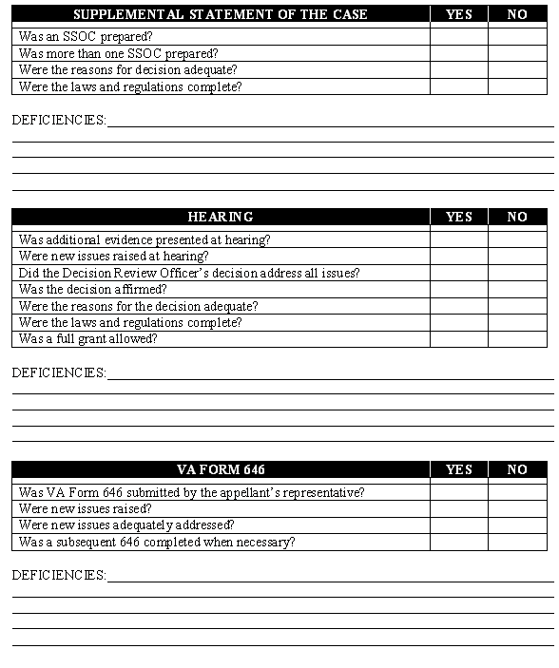
Continued on next page
31. Exhibit 1: Certification Worksheet, Continued

f. Certification Worksheet – Page 6 | Page 6 of a sample of the certification worksheet is below.

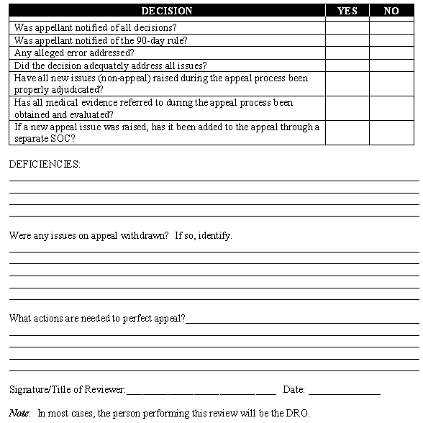

32. Exhibit 2: BVA Points of Contact

Introduction | This exhibit contains information on BVA points of contact.

Change Date | April 25, 2007

a. Team I ROs: Central Region | Point of Contact: Sondra Johnson  Telephone Number: (202) 565-5637  Status Calls: (202) 565-5436  Fax Number: (202) 565-4720  - Chicago, Illinois  - Cleveland, Ohio  - Des Moines, Iowa  - Detroit, Michigan  - Fargo, North Dakota  - Indianapolis, Indiana  - Lincoln, Nebraska  - Louisville, Kentucky  - Milwaukee, Wisconsin  - Muskogee, Oklahoma  - Sioux Falls, South Dakota  - St. Louis, Missouri  - St. Paul, Minnesota  - Wichita, Kansas
Continued on next page
32. Exhibit 2: BVA Points of Contact, Continued

b. Team II ROs: Southern Region | Point of Contact: Mary Short  Telephone Number: (202) 565-6255  Status Calls: (202) 565-5436  Fax Number: (202) 565-4720  - Atlanta, Georgia  - Jackson, Mississippi  - Little Rock, Arkansas  - Montgomery, Alabama  - Nashville, Tennessee  - New Orleans, Louisiana  - San Juan, Puerto Rico  - St. Petersburg, Florida

c. Team III ROs: Eastern Region | Point of Contact: Freddie Carelock  Telephone Number: (202) 565-4959  Status Calls: (202) 565-5536  Fax Number: (202) 565-4720  - Baltimore, Maryland  - Boston, Massachusetts  - Buffalo, New York  - Columbia, South Carolina  - Hartford, Connecticut  - Huntington, West Virginia  - Manchester, New Hampshire  - New York, New York  - Newark, New Jersey  - Philadelphia, Pennsylvania  - Pittsburgh, Pennsylvania  - Providence, Rhode Island  - Roanoke, Virginia  - Togus, Maine  - Washington, DC  - White River Junction, Vermont  - Wilmington, Delaware  - Winston-Salem, North Carolina
Continued on next page
32. Exhibit 2: BVA Points of Contact, Continued

d. Team IV ROs: Western Region | Point of Contact: Barbara Tapia  Telephone Number: (202) 565-9989  Status Calls: (202) 565-5436  Fax Number: (202) 565-4720  - Albuquerque, New Mexico  - Anchorage, Alaska  - Boise, Idaho  - Cheyenne, Wyoming  - Denver, Colorado  - Fort Harrison, Montana  - Honolulu, Hawaii  - Houston, Texas  - Los Angeles, California  - Manila, Philippine Islands  - Oakland, California  - Phoenix, Arizona  - Portland, Oregon  - Reno, Nevada  - Salt Lake City, Utah  - San Diego, California  - Seattle, Washington  - Waco, Texas

