Appendix BD:

VetSuccess Contract Funds

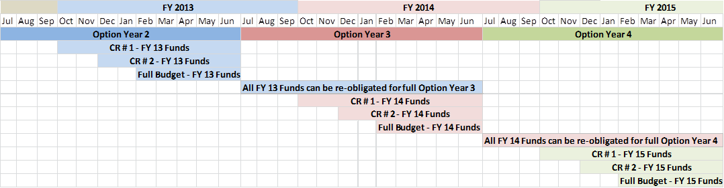

\* CR = Continuing Resolution