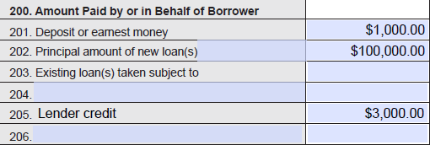
 | Itemization of
Credits “200 Series”
VA Case Number: | XX-XX-X-XXXXXXX (VA #)
Item: | 205 “Lender credit”
1 | Origination fee | $500
2 | Title service fee | $500
3 | Lenders title insurance | $2,000
 | Total | $3,000

3

